Star Athletic Alliance Recruiting Services
*** SPECIAL***
Class Of 2027 Student Athletes Are Eligible For A Full-Service Package At A Reduced Fee For A Limited Time Only. Includes Creation/Refinement Of Digital Presence And Assistance With College Recruitment. Don’t Hesitate! Contact Us Now At support@starathleticalliance.com
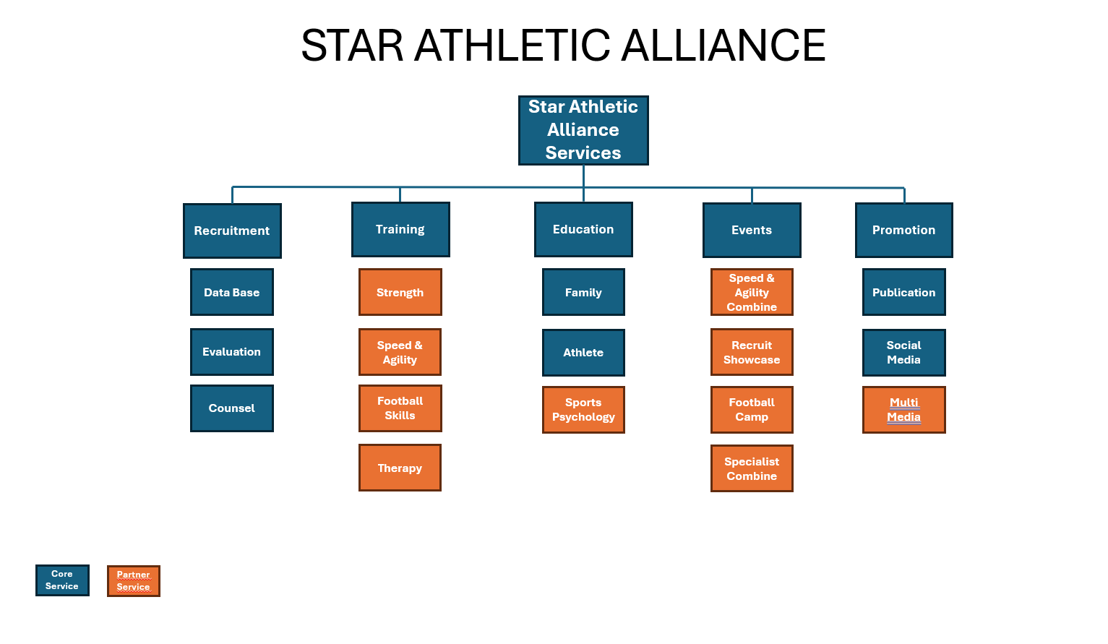
RECRUITING PACKAGE (Full Recruiting & Promotional Service)
Looking to add value and awareness to your recruitment? Star Athletic Alliance offers personalized recruiting services and advocacy for student-athletes at the high school level. While we are not an agency, we offer guidance, support, and resources to assist athletes unlock their full potential and make educated decisions to help them achieve their dreams.
We are not a replacement for the role of your high school coach! Our services are meant to complement the areas where there may be limited available resources and expertise.
----------------------
WHAT MAKES US DIFFERENT?
We are a regional organization whose focus is to service student athletes. We also partner with specialized services in the region, many of whom already service athletes attending high schools in our strategic geography.
Utilizing our recruiting services will gain access and discounts to training services and specific events with the purpose of further development and promotion of our student athletes.
WHAT DOES OUR RECRUITMENT SERVICE INCLUDE?
We start with a personalized recruiting profile for use to both promote and guide the student athlete. We will provide added film assessments and review academic readiness where available. This information is the basis to begin development of promotion media and publication content. These will be monitored for progress through regular check-ins.
Increased Visibility: Our strategic social media will assist student athletes to increase exposure to a specific audience and attract college recruitment.
  - We provide quality graphics uniquely designed for the student athlete. These are leveraged to increase the athlete’s digital profile and presence.
- Student athletes will be spotlighted in articles that will provide comprehensive online awareness of their achievements and potential.
- We provide ongoing evaluation, valuable insights into strengths and areas for improvement, to assist the student athlete gain understand their current standing and potential for growth.
Strategic Event Access: We provide access to training and data gathering events through specific skill events and evaluation-based camps. These will aid the student athlete identify opportunities that align with their skills. This will in turn increase their opportunities for recognition and recruitment.
Digital Proficiency: We will work with student athletes to enhance their use of digital platforms, to showcase their skills effectively and efficiently.
Strategic Referrals: We will work with student athletes to target programs that align with their skills and academic achievements through monthly engagement consultations.
Informed Decision-Making: We will provide guidance in the recruiting process to empower athletes and their families to make informed decisions about their athletic and academic future.
HOW DO WE START?
We offer a no-cost introduction call that will review background information specific to the athletes’ interests and introduce our team. Parents and guardians are encouraged to participate. Information sessions are available through our website or by contact at support@starathleticalliance.com
WHAT HAPPENS NEXT?
When a client has decided to partner with Star Athletic Alliance, we will provide a questionnaire and conduct a more formal conference call that builds a detailed academic, social and athletic profile.
ONGOING COMMUNICATION
We will provide ongoing communication specific to any questions and required guidance. We will also provide continued evaluation, and identification of strengths and areas for improvement, to assist the student athlete gain understand their current standing and potential for growth.

FAQS
Do you offer payment plans or deposits?
Yes, we offer flexible payment plans for select services. Payment plan options will be presented during your consultation, depending on the service.

Are there any hidden fees?
No, there are no hidden fees. Each service is offered combined or a la cart at a flat rate. Customized services will be considered on a per case basis.

Termination and Refunds
Either the client or Star Athletic Alliance may terminate the service agreement at any time by providing written notice. In the event of termination, services will cease immediately upon notice.
​Please note:
All payments made are non-refundable. This includes any partial or full payments for services rendered or scheduled.
We encourage all clients to carefully review service agreements before commitment and to reach out with any questions prior to booking.
** If you have any questions before booking services, please feel free to contact us at support@starathleticalliance.com

